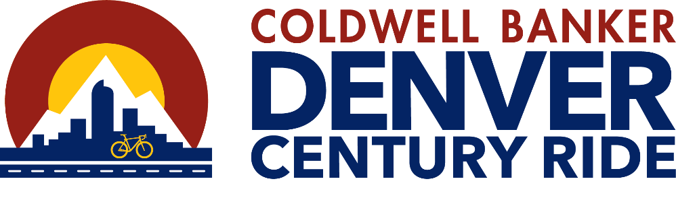

FOR MORE INFORMATION
Bruce L. Erley
Creative Strategies Group
720-840-1974 (Mobile)
berley@csg-sponsorship.com

Denver’s Epic Urban Cycling Tour Returns on September 28, 2024

FOR IMMEDIATE RELEASE

DENVER, CO. – Nearly 2,000 cyclists will experience Denver’s most bikable streets, dedicated lanes, trails, and parks on Saturday, September 28, 2024, at the Coldwell Banker Denver Century Ride.

Celebrating its 13th year, this legacy bike tour provides cyclists of all abilities the opportunity to discover Denver on two wheels as they “cycle the city.” Starting and ending at The Shops at Northfield in Central Park, (8340 Northfield Boulevard, Denver, CO 80238), the Ride provides four courses, 100 miles, 85 miles, 50 miles, and 25 miles, showcasing many of the bicycle commuter routes that connect the city and surrounding communities.

The Denver Century Ride’s four courses link cycling lanes, roadways, and biking paths that intertwine throughout the city for a casual cruise, a commute, or a challenging workout. Cyclists will roll past Union Station and Coors Field and through city parks. Based upon their selected distance, they can challenge themselves to climb Lookout Mountain and coast along the Hogback.

(more)
2024 Denver Century Ride – Add 1

“What makes the Denver Century Ride so unique is its complexity,” explained Ride Director Sabra Nagel. “Producing a ride in an urban area like Denver and the surrounding municipalities requires a lot of cooperation and support from all the entities touched by the cyclists. The Cities of Denver and Lakewood have been gracious in permitting us to traverse their parks using a network of multi-use trails. This permission is special to the Denver Century Ride, she said”

“In addition, the Denver Police Department supports the ride with more than 50 officers to make sure the first 16 miles are as much of a rolling parade as is practical. Once the longer routes roll out of the city the support continues with assistance from the Colorado State Patrol, City of Golden PD, Jefferson Co Sheriff’s Office, Town of Morrison PD, Littleton PD, and Cherry Hills Village PD. Every community the ride touches reviews the route provides suggestions, and determines where support is needed,” Nagel added.

This is a fully supported ride with aid stations, course marshals, and bike mechanics from Epic Mountain Gear, as well as meals & nutritional supplements to meet the needs of cyclists of all experience levels and abilities.

Considered by many to be Denver’s best post-ride celebration, cyclists as well as their families and friends are invited to celebrate their achievement at the Breckenridge Brewery Post Ride Street Party at the Shops at Northfield Stapleton. Family members are encouraged to join the spirit of celebration, frosty beers, fantastic food options, and a lifestyle expo, making a perfect finale for a great day on the bike.

(more)

2024 Denver Century Ride – Add 2

The Coldwell Banker Denver Century Ride is a Champion Partner of Bicycle Colorado providing more than $100,000 to the state’s leading cycling advocacy organization. “This partnership allows us to execute our mission which is all about ensuring that every person who wants to ride a bike has access to safe cycling,” commented Pete Piccolo, Executive Director of Bicycle Colorado.

Last year a total of $25,000 was directly contributed by the ride to local charitable organizations including Bicycle Colorado. Further in 2023, the ride’s Charitable Partners Program generated more than $200,000 in fundraising pledges and donations for nonprofit causes.

For detailed route descriptions, complete event information, and updates, or to register for the ride visit DenverCenturyRide.com. Like us on Facebook at Facebook.com/DenverCenturyRide

The 2024 Coldwell Banker Denver Century Ride is presented by Coldwell Banker in association with The Wilhite Law Firm, Primal Wear, The Shops at Northfield, and Epic Mountain Gear. Supporting Sponsors include Breckenridge Brewery, the Colorado Lottery, the Regional Air Quality Council, and 5280 Denver’s Mile High Magazine. Eldorado Natural Spring Water, Frame de Art, Cycling360, Xfinity, and City Cast Denver are Contributing Sponsors.

###

